**LARGEST NUMBER IN AN ARRAY**  
  
**EXP NO: 10**  
  
**AIM:** To find the largest number from an array using 8085 processor.  
  
**ALGORITHM:**  
  
1)      Load the address of the first element of the array in HL pair.  
  
2)      Move the count to B register.  
  
3)      Increment the pointer.  
  
4)      Get the first data in A register.  
  
5)      Decrement the count.  
  
6)      Increment the pointer.  
  
7)      Compare the content of memory addressed by HL pair with that  
of A register.  
  
8)      If carry=0, go to step 10 or if carry=1 go to step 9  
  
9)      Move the content of memory addressed by HL to A register.  
  
10)  Decrement the count.  
  
  
   
  
  
**PROGRAM:**  
  
  
LXI H,2050  
  
  
MOV C,M  
  
  
DCR C  
  
  
INX H  
  
  
MOV A,M  
  
  
LOOP1: INX H  
  
  
CMP M  
  
  
JNC LOOP  
  
  
MOV A,M  
  
  
LOOP: DCR C  
  
  
JNZ LOOP1  
  
  
STA 2058  
  
  
HLT  
  
  
   
  
  
**INPUT:**

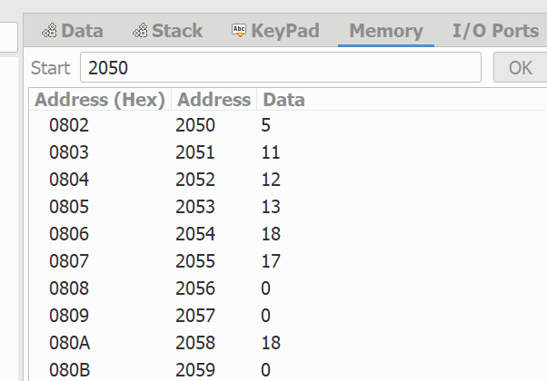  
  
  
   
  
  
  
  
  
**OUTPUT:**

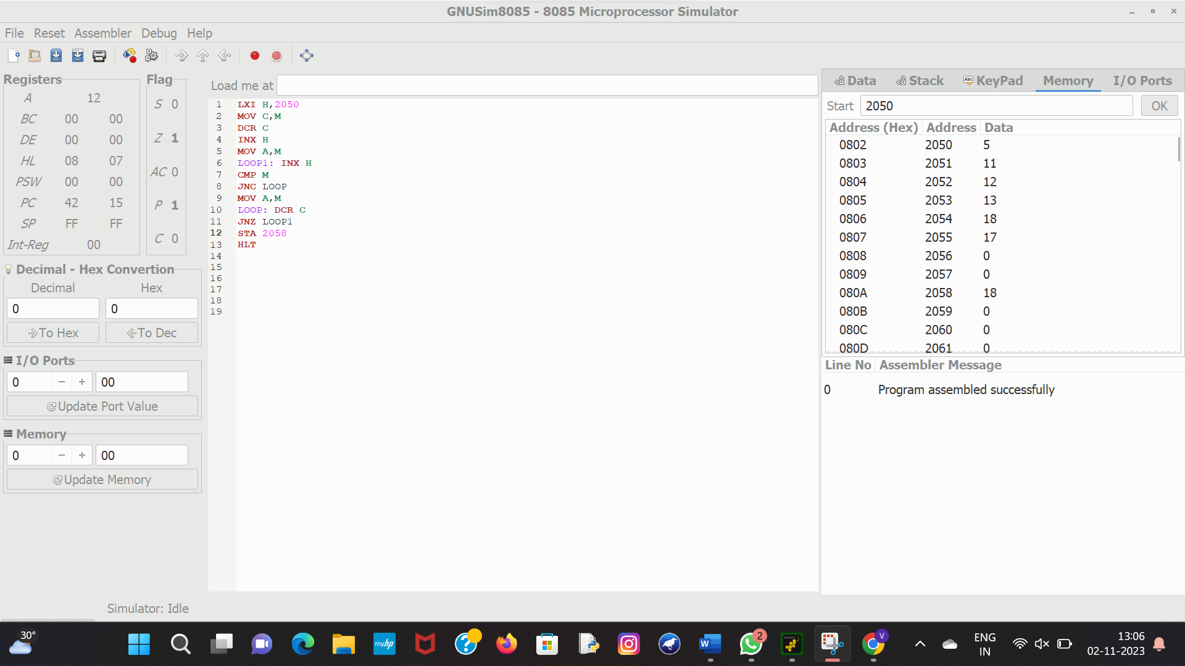  
  
  
   
  
  
  
  
  
**RESULT:**Thus the program was executed successfully using 8086 processor simulator.